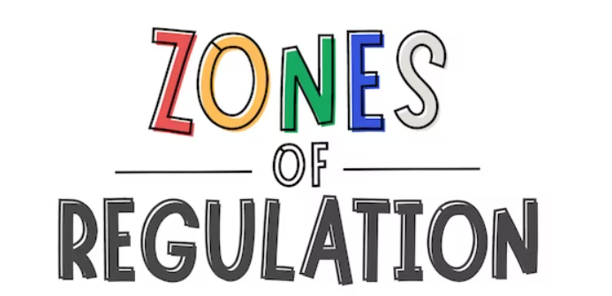 Zones of Regulation is a framework used to help children understand and manage their emotions and develop self-regulation skills. It categorises emotions and alertness levels into four color-coded zones: Blue, Green, Yellow, and Red. Each zone represents a different state of alertness and associated emotions, providing children with a common language and strategies to navigate their feelings.

Here's a breakdown of each zone:

**Blue Zone:**

This zone represents low states of alertness, such as feeling sad, tired, bored, or sick. It's a time for rest and recharge.

**Green Zone:**

The Green Zone is a calm, regulated state of alertness, where individuals feel happy, focused, content, or ready to learn. It's the ideal zone for engaging in tasks and interacting with others.

**Yellow Zone:**

The Yellow Zone represents a heightened state of alertness and strong emotions, such as stress, frustration, anxiety, or excitement. While still in control, it requires mindful attention to manage these heightened emotions.

**Red Zone:**

The Red Zone signifies a highly intense state of alertness and emotions, like anger, rage, or feeling overwhelmed. It's a time to prioritise safety and de-escalate the situation.

